Beginning in 2015 any parcels that are identified as “Covenant Housing” that are subject to a reduction in the ‘Real’ value, this will be set up the following way. Find the parcel in ‘1 Parcel Maintenance’. On the ‘Parcel’ tab enter the percent that the parcel will be reduced by as seen below on the left. We have entered 30.00 in that field which translates to 30 percent. Next go to the ‘Value/Exempt’ tab and enter the parcels value in as ‘Real’ value minus ‘Covenant Housing’ reduction as seen below on the right. (You may not have access to these fields if your CAMA program sends values to the Grand List program. If this is the case then you will have to adjust the values in your CAMA program). You may contact the Vermont Housing and Conservation Board at 802 828 2965 for information on parcels within your town.

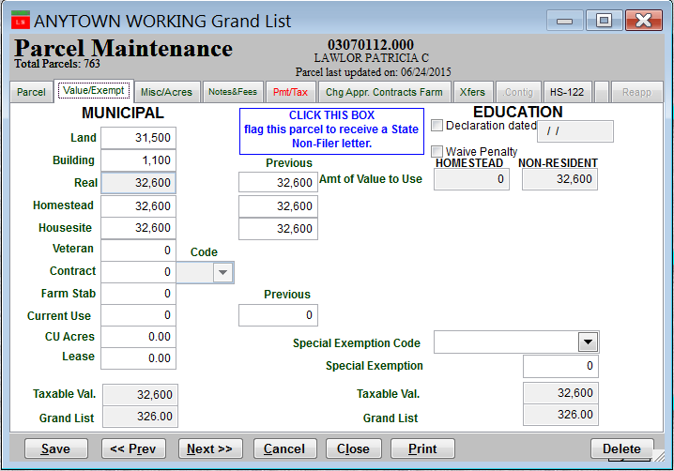
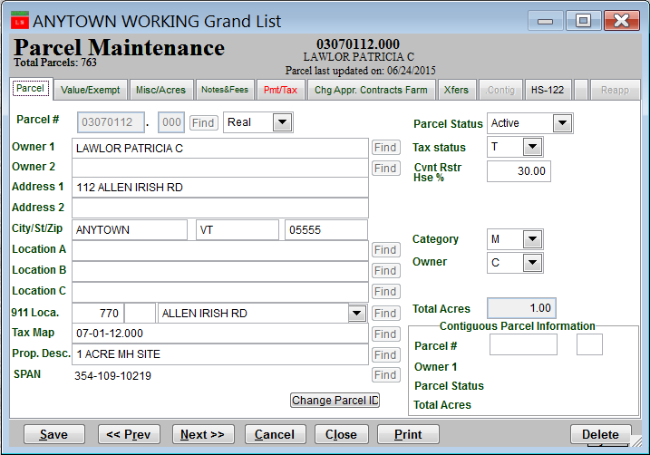

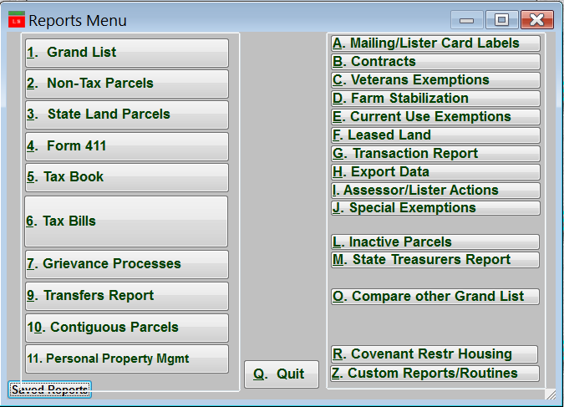

Next go to the ‘Reports’ menu and
select the ‘R Covenant Restr Housing’ report
to see all of the parcels that have been adjusted for
a Covenant Restricted Housing percentage.

